Hi Michael,
Thanks for your call today. Here is the list of things I need your help with. The ultimate goal is to have a product designer that can
- Be added to the Woocommerce Cart

- I believe you just need to set a price for the item and possibly set the product type and the Product Data to ‘Simple product’ in the dropdown, and the ‘Add to cart’ should automatically be displayed.

- Be priced differently for prices front and back. Price of back will probably be an additional fee.

- This can be done pretty easily it looks like. Basically, select ‘Fancy Products’ under ‘Fancy Product Designer’ in the admin panel. Click on the desired product to expand it so all the views (front, back, etc) are visible. Press the ‘Edit Options’ icon for a view to set its price. There are options for setting prices for text or images. That’s about it. Some instructions are here:

http://support.fancyproductdesigner.com/support/solutions/articles/5000587408-setting-different-prices-depending-on-the-customized-view

- Looks like it is part of my website (not an add on), with similar color palette
  - Ideas: Customize colors and look of the canvas

- To set the colors, select Fancy Product Designer → UI Layout and Composer → Color Tab and there are several options to change colors of specific areas of the canvas. You are given the option to change the color using a color tool or by changing the 6 digit hex value.

These are some of the hex values for colors on your site

- main header color: #16253D
- header text color: #6C7A89
- logo accent: #A99452

This should be pretty easy for you to change but let me know if you have any problem.

- It is easy to use, works in a mobile application

  - See examples below for pop ups. Also could customize the I button. I like the feature of a popup as it can be used in many ways.

- I created a basic plugin that will provide tips overlays similar to the examples from the tattoo site. These were not options that were available from FPD, but required customization.

It’s very easy to add info to the ‘i’ icon. Just go to ‘Settings’ in ‘Fancy Product Designer’ in the admin panel, select the ‘Label’ tab and scroll down to the ‘Info Content’ option. Change the text here to the custom text you would like to have appear in the popup. Note: Adding this popup may now be redundant if you want to use the other popups I created. It might be better to just remove this icon so your cnavas is less cluttered. This is just a thought. Please do what you think is best.

- Add Fancy Product Designer Plus Add On Free Drawing Module

- This shouldn’t be difficult to activate. I can walk you through it over the phone if you want.

- Exports the designs only (not the image) to a pdf file so it can be used as is to engrave

- Yes this can be done. I found a link to good explanation on YouTube below. I can also walk through this with you. Essentially, when you receive an order, you will need to select the ‘Orders’ option under ‘Woocommerce’ in the admin panel. You then select the specific order you have received from the list, press the ‘Load Order’ button which will load the layers of the order into the FPD canvas. You can select the orders you want have exported in the final image by selecting the ‘Manage Layers’ button on the canvas. Press the ‘x’ icon on each layer you want to exclude.

If you want the final image to have a transparent background go to the ‘Export’ tab below the canvas, select the ‘Image’ option for output file and ‘SVG’ for the image format.

Then press ‘Create’ and the image should be downloaded and you should be good to go!

(Sorry this url wrapped onto two lines):
https://youtu.be/0g4X4-9x5cM? list=PLGgK_C7xU0ilfND14GyPd3RzKmSqd3P4r&t=1172

Example ` MOMENTARY INK (They use Fancy Product Designer)
https://www.momentaryink.com/product/custom_tattoo_design_builder/
What I like:
- Ability to Click to get Instructions
- Clear Instruction on Front Page

- Customized Colors
When You Click on Add Image, you get Image Tips that goes to a Pop Up
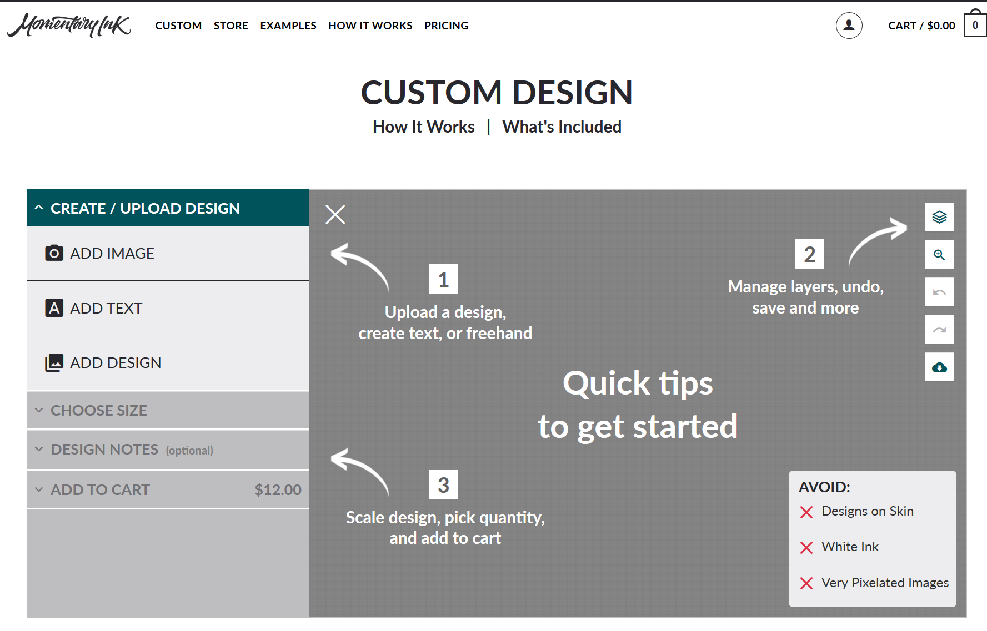

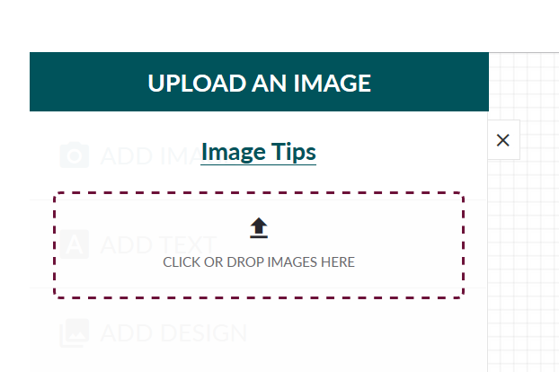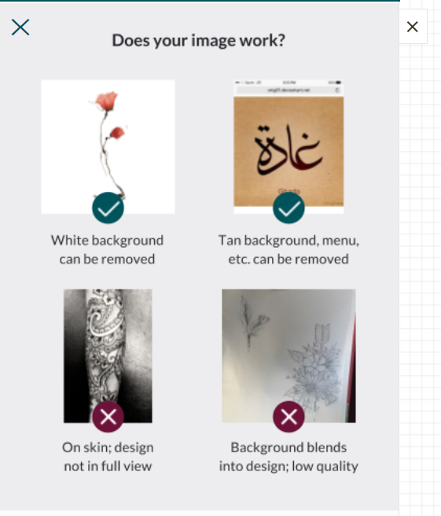

Example 2 – Road ID
https://www.roadid.com/builder/id/default.aspx?styleid=366#/personalize

What I Like

Popup with Medical Abbreviations

https://www.roadid.com/builder/id/default.aspx?styleid=366#/personalize
